README

This is my implementation of a sliding window, stop and wait, server reliable / unreliable algorithms. Homework 3 for CSS 432.

Here’s some visuals for the concepts behind the algorithms.

**Discussion:**

Stop-and-wait is as stated before is a positive acknowledgement with retransmission. The total time taken for this transmission of 20,000 was 3545304 usec. While the sliding window for the same message size (window size 30) was 2643052 usec. There are a lot of factors that contribute to the times, how many people are using the linux lab servers at the same time, the bandwidth that the servers have to communicate with each other, and the algorithm itself. While the sliding window is a more reliable way of sending information, it takes longer because it has to wait for acknowledgment for every data packet that is sent through the wire. The sliding window can send data through the wire that is less than or equal to the window size which allows for the server to get and ACK more data packets. Sliding window is used in practice more than stop-and-wait for this reason. Both Stop and Wait protocol and Sliding Window protocol are the techniques to the solution of flow control handling. The main difference between stop-and-wait protocol and sliding window is that in stop-and-wait, sender send one frame and wait for the acknowledgment from receiver side whereas in sliding window protocol, sender send more than one frames to the receiver side and re-transmit the frame which are damaged or dropped.

**Stop and wait:**

(sometimes known as "positive acknowledgement with retransmission") is the fundamental technique to provide reliable transfer under unreliable packet delivery system. After transmitting one packet, the sender waits for an acknowledgment (ACK) from the receiver before transmitting the next one. In the sliding window technique, each data packet and byte include a unique consecutive sequence number, which is used by the receiving computer to place data in the correct order.

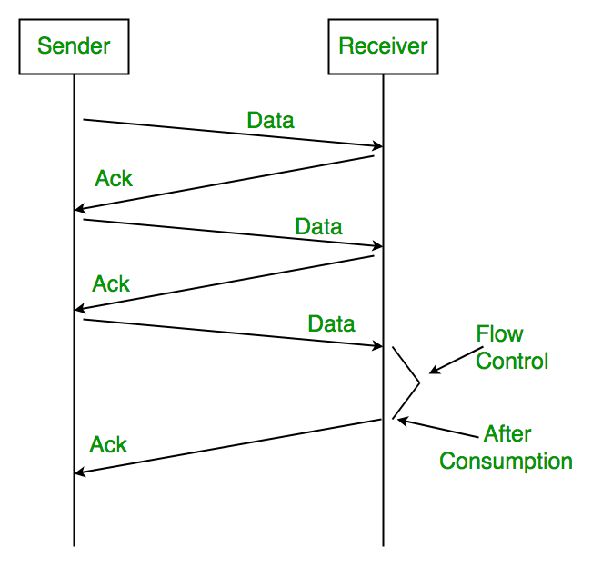

**Sliding window:** (tested with window size 1 and 30, with a percent drop of 1-10%)

Sliding window is a technique for controlling transmitted data packets between two network computers where reliable and sequential delivery of data packets is required, such as when using the Data Link Layer or Transmission Control Protocol.

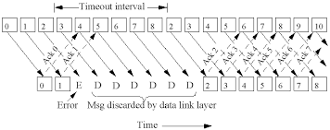

**Spread Sheet, Screen Shot:**

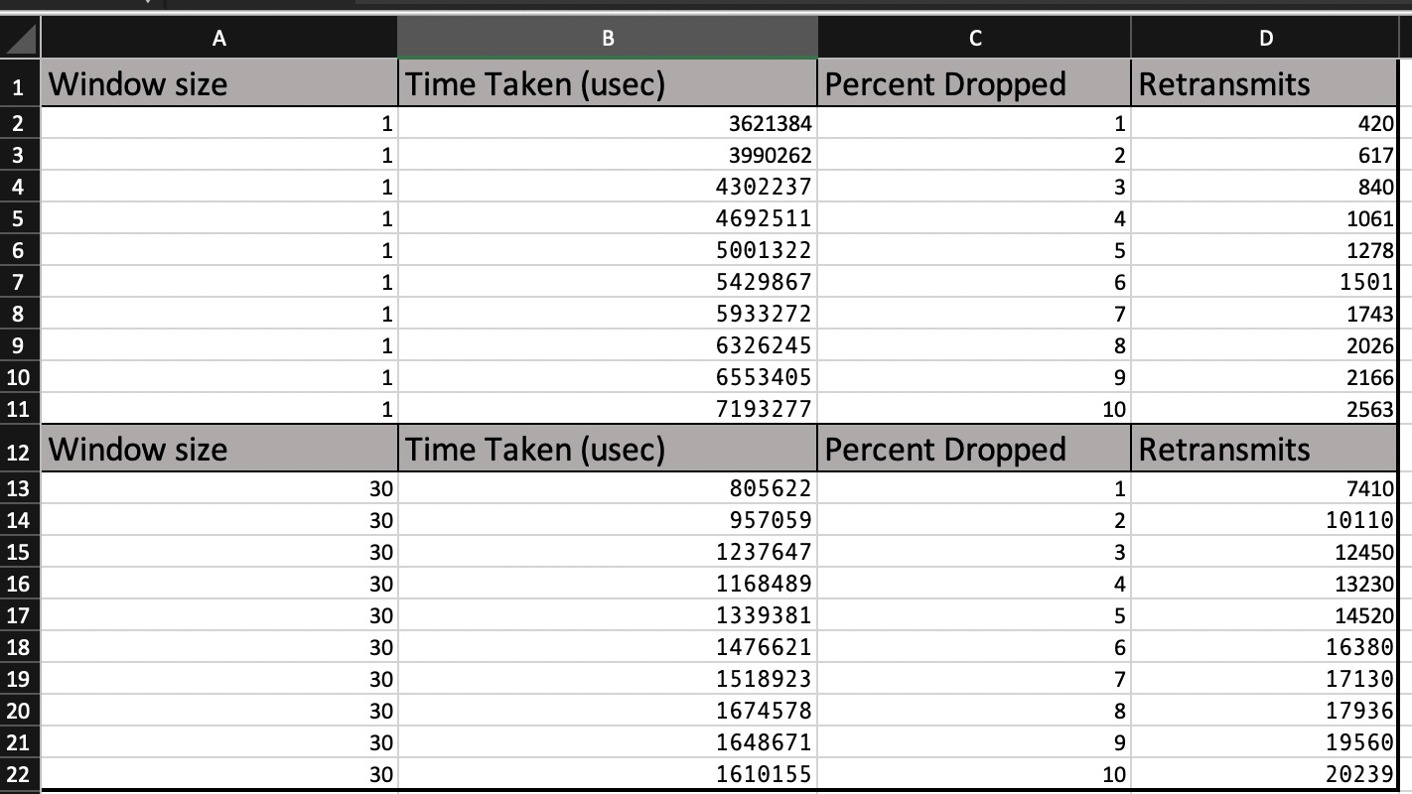

**Plots: (1 gbps stop and wait test case 2, window size 1 test 4, window size 30 test 4)**







**Output Screen Shots:**



